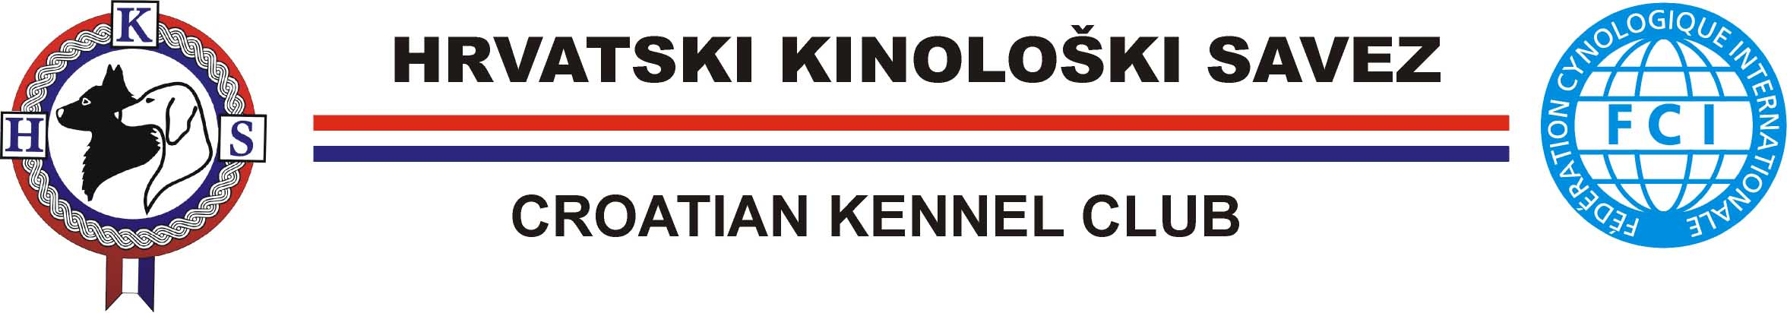
PROVISIONAL PROGRAM

From February 19th till February 25th :
CACT / CACIT Trials for Continental Pointers

Sunday February 26th :
Falkensteiner Club Funimation Borik :
16.00 h : National Teams and Jury Presentation Parade
19.00 h : Meeting of the F.C.I. Continental Pointers Comission
20.00 h : Drawing of the lot
21.00 h : Official dinner

Monday February 27th :
07.30 h : Departure to the fields
Competition of the European Cup for Continental Pointers
19.30 h : Rapports, final results and award giving.

Tuesday February 28th :
07.30 h : Departure to the fields
Competition of the World Champioship for German Pointers

Wedneday February 29th :
07.30 h : Departure to the fields
Competition of the World Champioship for German Pointers
19.30 h : Rapports, final results and award giving.

Thursday March 1st :
07.30 h : Departure to the fields
Competition of the World Champioship for Epagneul Breton

Friday March 2nd :
07.30 h : Departure to the fields
Competition of the World Champioship for Epagneul Breton
19.30 h : Rapports, final results and award giving.

